Ethics is Advertisement
Student’s Name
Institutional Affiliation
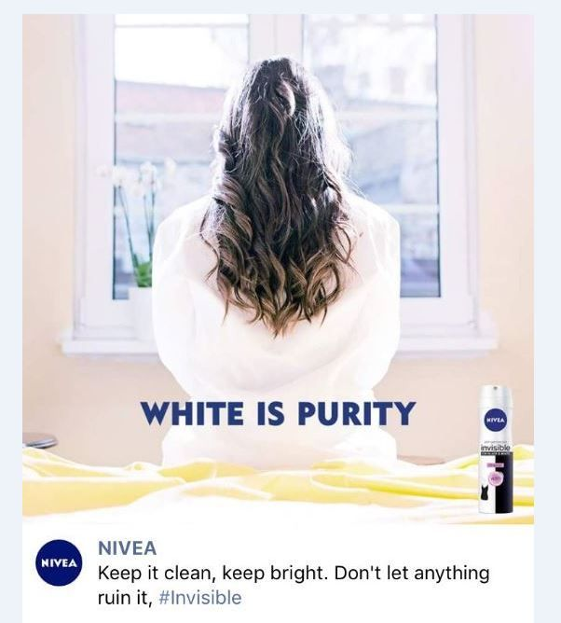
The offensive elements in the Advertisement by Nivea are the words and color used. The words "White is Purity" are controversial for they promote racism. The marketing post is therefore racist and encourages discrimination. From the Advertisement by Nivea, the company perceived white to be pure and perfect. The company did not realize that the message from the campaign illustrated that using the skin and body products of Nivea would make one white and pure. Therefore, the post is offensive as it portrays the inferiority of dark skin, which then encourages racism and discrimination.
Nivea is a company that deals with skin and body care products. The intended audiences for the Advertisement are women regardless of their culture. The brand had a marketing campaign to increase the product awareness to women worldwide to choose Nivea for being pure.
The Advertisement is inappropriate for its intended audience. It would be appropriate if the Advertisement were able to consider the diverse cultural needs of women. The African American audience would perceive the marketing strategy to be racist and disrespectful of the dark skin. The Advertisement is inappropriate for the intended audience based on the message "White is Purity," which promotes white supremacy.
The advert pushes the limits of ethical Advertisement and social responsibility as it increases discrimination and stereotyping. For example, from the campaign, the audience would stereotype that dark is inferior and thus discriminating against African Americans. To be more socially responsible, the marketer could have considered avoiding sensitive word that deals with race and discrimination. For example, the remarks "White is Purity" are racist, especially for non-White audiences. Also, the marketer needs to understand the targeted audience and thus avoid cultural blunders by meeting its diverse customers' needs.

